USB Research:

Basic info we could add (history):

* Smart building – windows, AC, security is all automated, no need for human interaction.
* £60 million to build takes up 12,000sqm.
* 1200 student’s capacity as well as 55 academics.
* Awarded the Newcastle Lord Mayor’s Design Award for Sustainability.
* Building creates 33,000 kWh/ year of energy which saves 19,000 kg of CO2 per year.
* Wild flower meadow on the roof of the building.

What’s inside the building (Research categories):

* Bio and neuro-computing.
* Cloud computing
* Cyber-physical systems/ cyber security.
* Data visualisation
* Games engineering
* Scalable computing (micro computing).

Awards given to the building:

* **Green Gown Awards 2018** - Campus of the Future - Winner
* **Education Estates Awards 2018** - Innovation in Teaching and Learning - Winner
* **RICS North East Awards 2018** - Design Through Innovation - Winner
* **Constructing Excellence Awards 2018** - Building of the Year, Integration & Collaborative Working, Sustainable Building, Digital Construction, Off Site Manufacturing - Winner
* **Lord Mayor's Design Awards 2018** - Sustainability - Winner

Floor plans and what each room is:

* 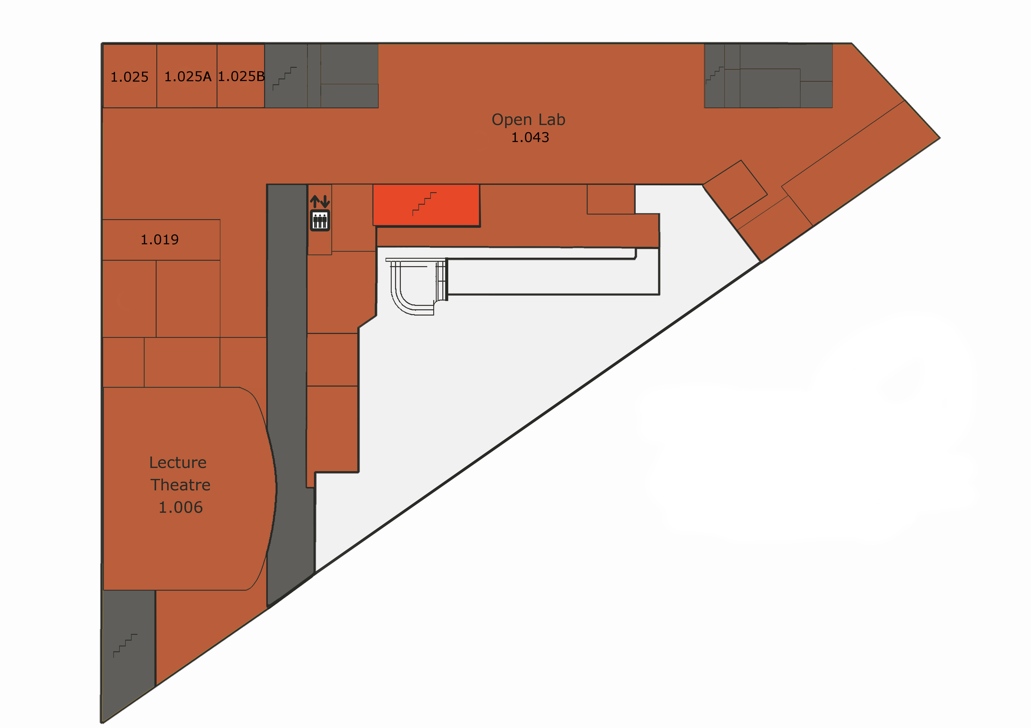1.006: main lecture hall
* 1.043: open lab – research lab
* 1.019:
* 1.025:
* 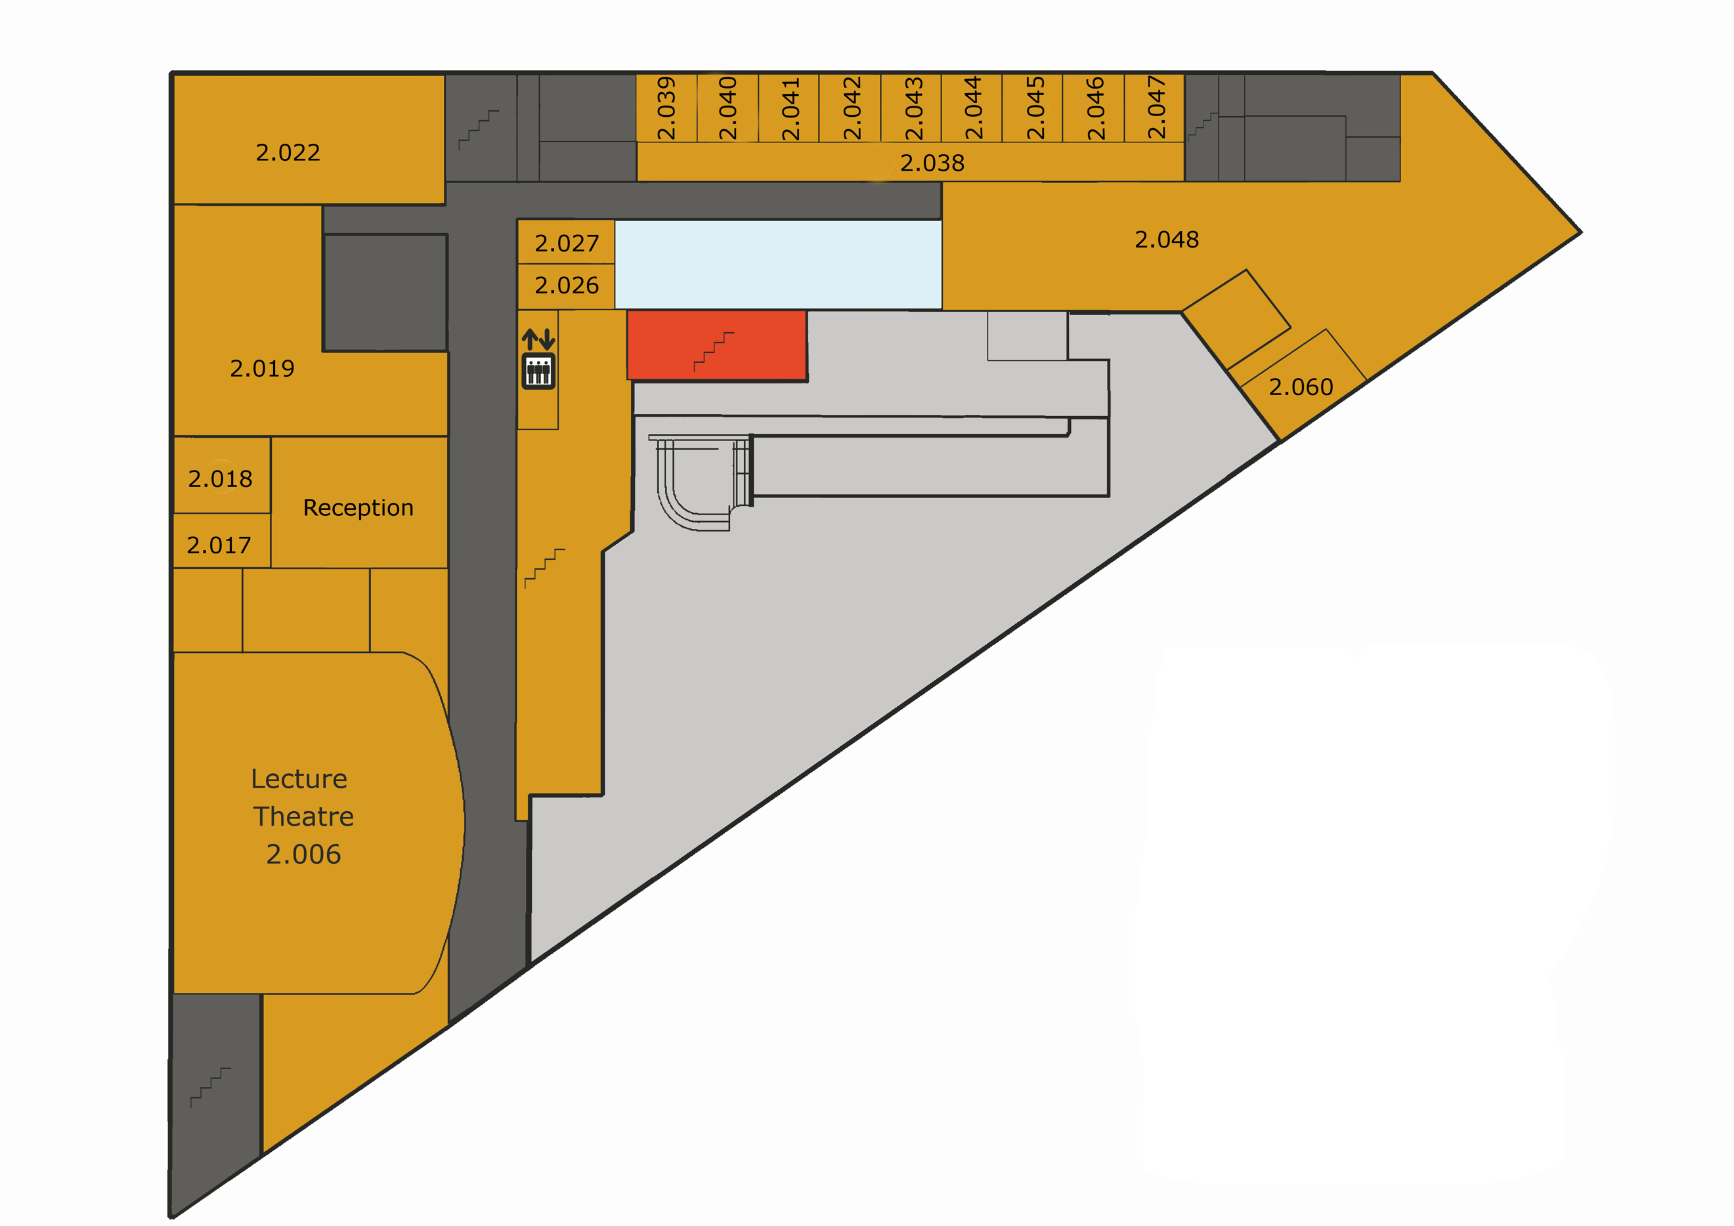2.006: top of lecture hall:
* reception: School reception
* 2.017/ 2.018: Prof John Fitzgerald HOS.
* 2.019: Computer work space
* 2.022: Computer work space
* 2.026:
* 2.027:
  + - * 2.038: Access to offices on floor 2. + Dr Jennifer Warrender.
* 2.039: Dr Marie Devlin.
* 2.040: Ms Laura Heels
* 2.041: Dr Steve Riddle
* 2.042: Dr Lindsay Marshall
* 2.043: Dr Ellis Solaiman
* 2.044: Dr Nick Cook
* 2.045: Dr Neil Speirs
* 2.046: Dr Alan Tully
* 2.047: Dr John Colquhoun
* 2.048: Work Space
* 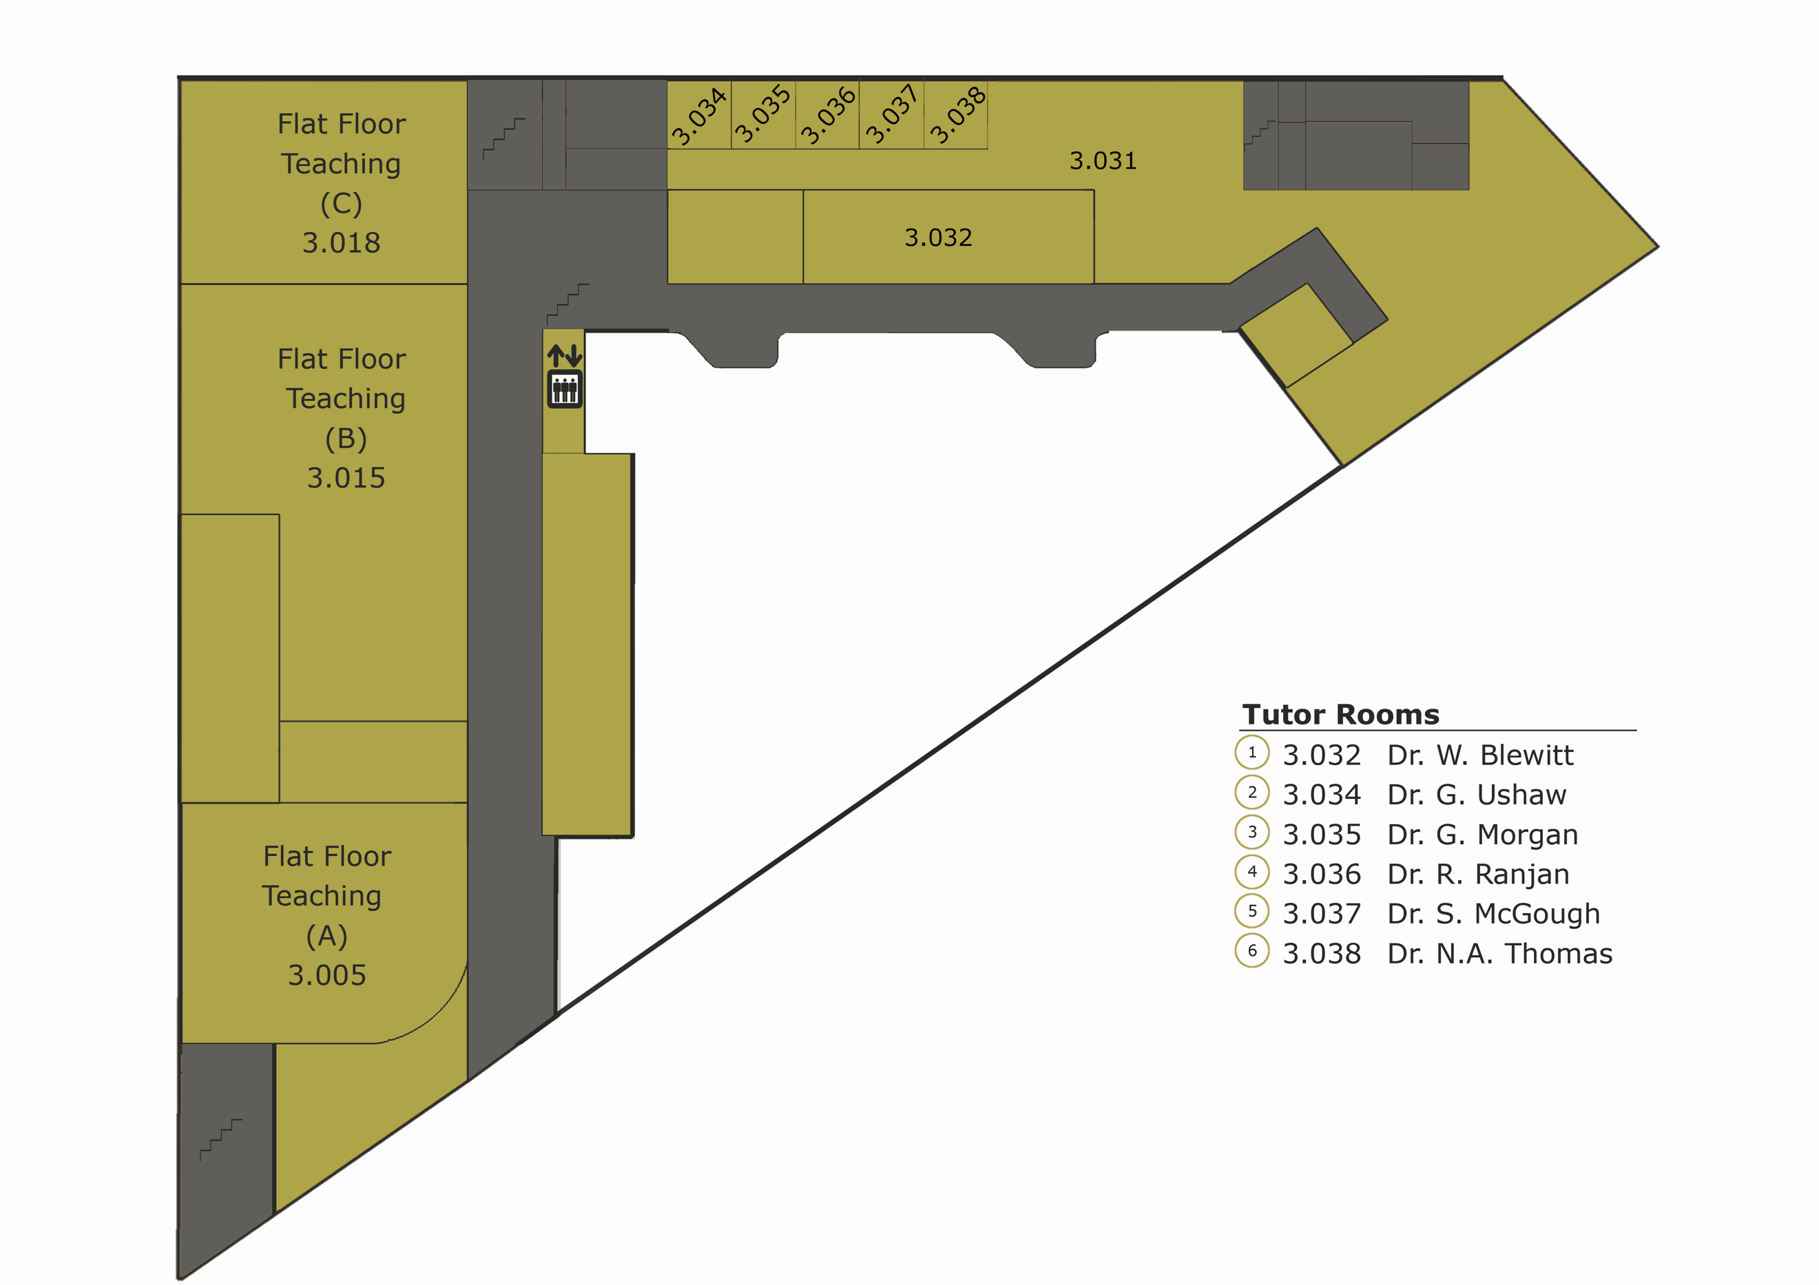2.060: Work space
* 3.005: Computer Clusters/ Practical room.
* 3.015: Computer Clusters/ Practical room.
* 3.018: Computer Clusters/ Practical room.
* 3.031: Work Space.
* Tutor rooms on photo.

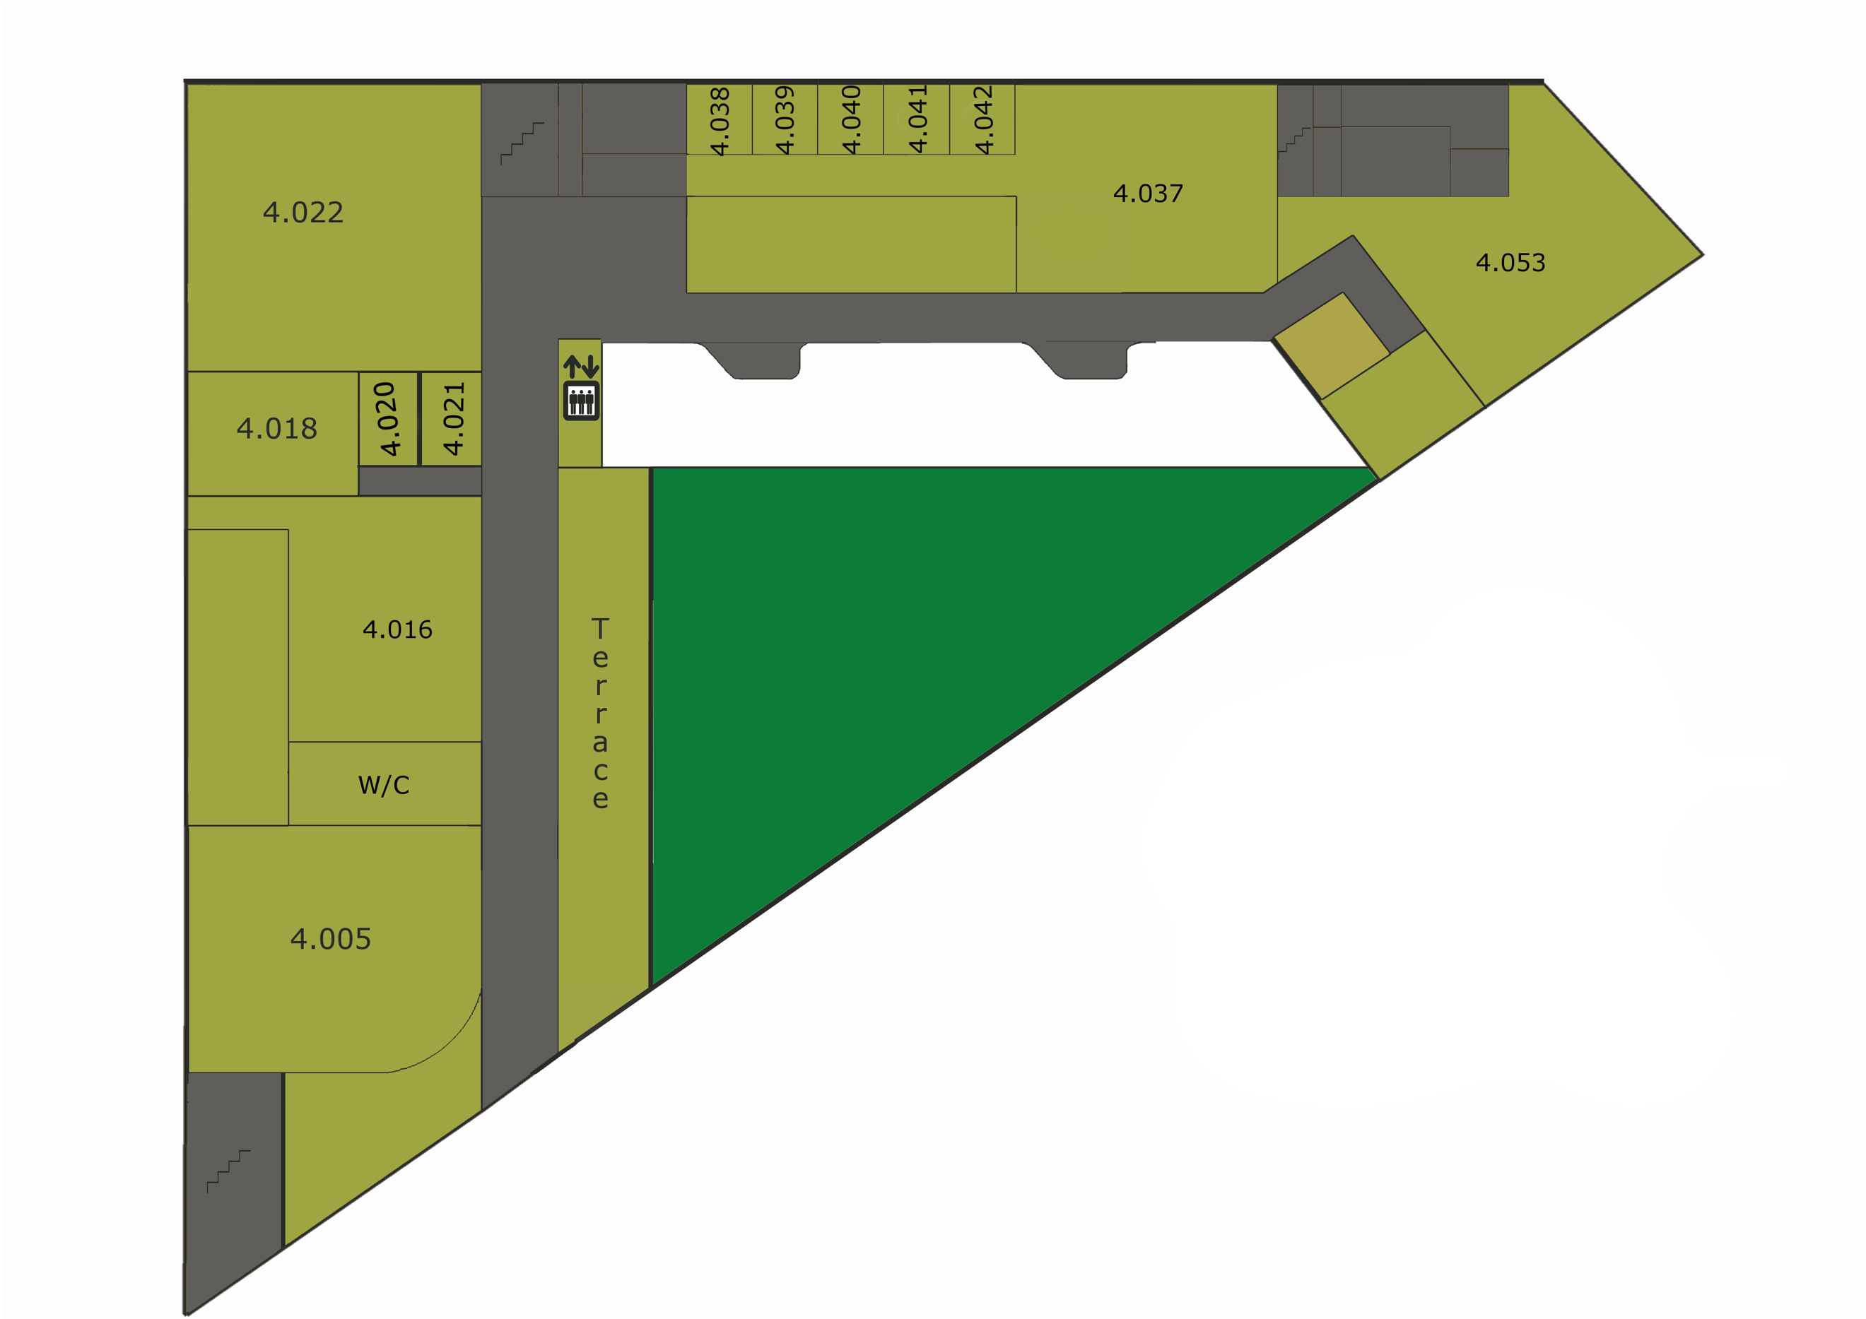

* 4.005: Small Lecture Hall/ Assembly Hall.
* 4.016:
* 4.018: Small Practical room.
* 4.020: Computer Work Space
* 4.021: Computer Work Space.
* 4.022:
* 4.037: Work Space
* 4.038:
* 4.039:
* 4.040:
* 4.041: Dr Paolo Missier
* 4.042: Dr Sara Fernstad
* 4.053: Work Space

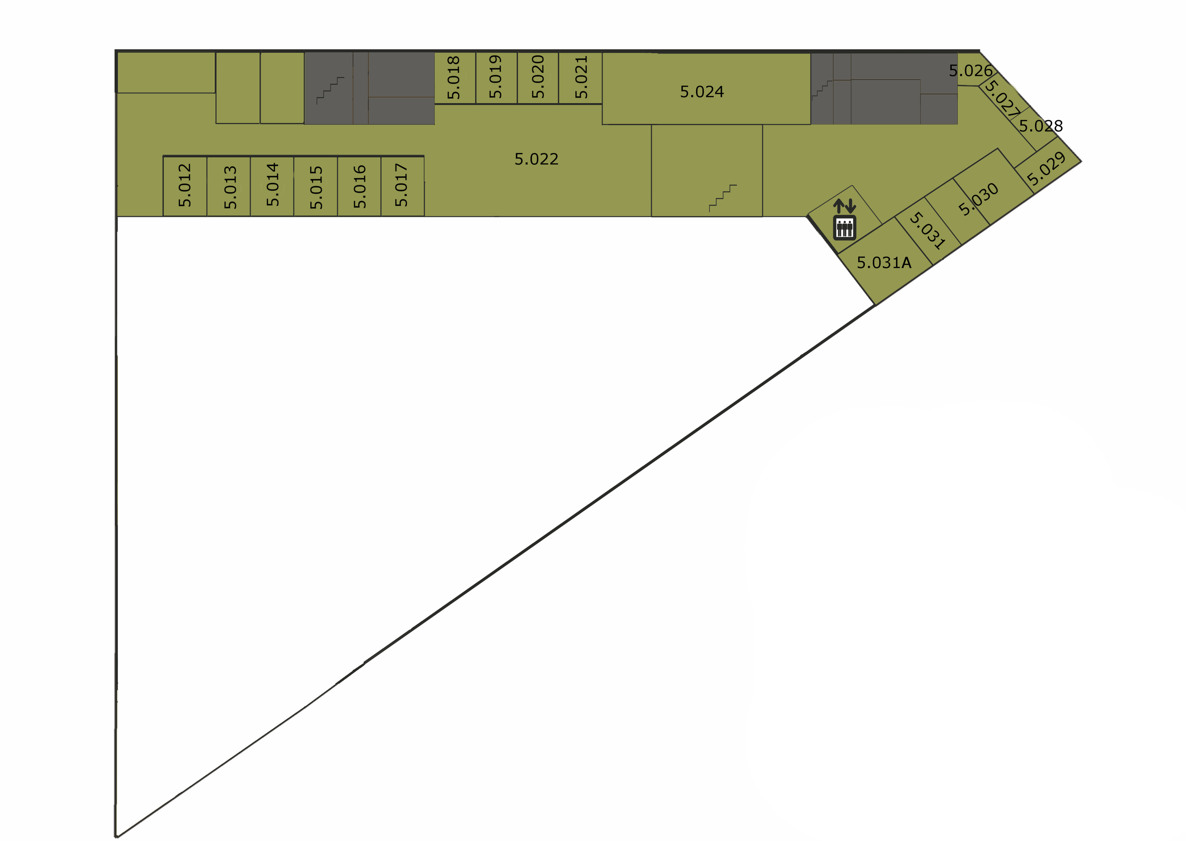

* 5.012: Dr Phillip lord
* 5.013: Dr Paolo Zuliani
* 5.014: Dr Angel Goni-Moreno
* 5.015: Dr Harold Fellermann
* 5.016:
* 5.017:
* 5.018: Prof Anil Wipat
* 5.019: Prof Marcus Jaiser
* 5.020: Dr Jaume Bacardit
* 5.021:
* 5.022: Work Space
* 5.024:
* 5.026: Dr Victor Khomenko
* 5.027: Dr Jason Steggles
* 5.028: Dr Maciej Koutny
* 5.029: Prof Marta Koutny
* 5.030:
* 5.031: Dr Paul Ezhilchelvan